From Vienna to Bratislava on a bicycle

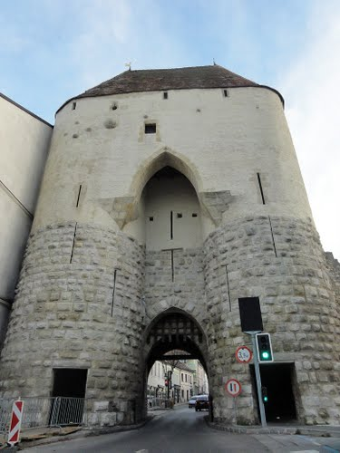
It is about 80km on a bike to Bratislava from Vienna, all on bike trails. You ride 60km on the Danube’s left bank, cross the Danube at Hainburg and then ride approximately 20km on the right bank to the bridge re-crossing the Danube at Bratislava. The city gates in Hainburg are a must see and it is a good place to rest and have something to eat.
The ride to Hainburg takes you through the forest flood plain along the Danube, of which you can catch occasional glimpses through the trees. Be sure to take enough to drink and a snack as there are no refreshment stalls directly on the trail until you cross back over the river.
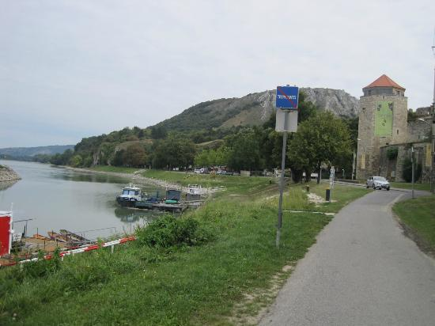

Train journey to Prague

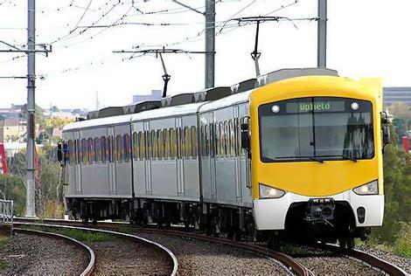
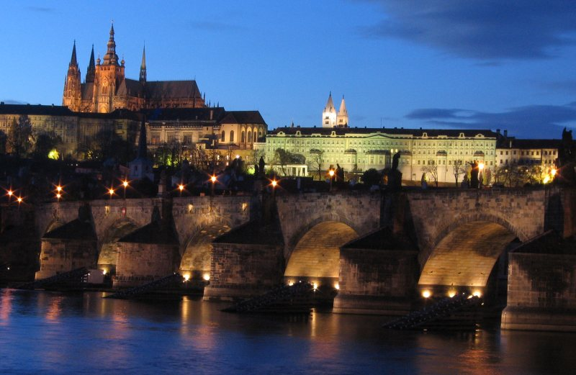
Train journey to Prague takes about 3-4 hours, if you want to get there. Trains depart from Bratislava Main Railway Station and cross borders to the Czech Republic. The first thing, you should do, is to go to the railway station and buy a ticket. One way ticket is usually more expensive than the return ticket, which is valid one month. I usually make also a reservation, so I don’t have to be afraid, if there is a free seat in the compartment. Then you go directly to your platform and wait until your train arrives. After you arrival in Prague, you should definitely see Prague Castle – that’s a must. It takes only about 15 minutes to get there by bus number 77.

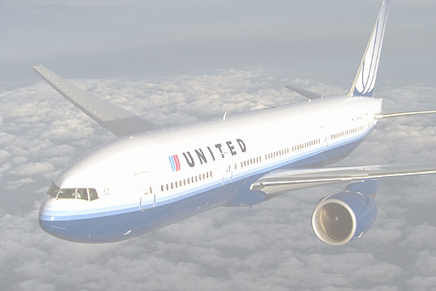
Flight to London

After I had decided to travel to London I bought a ticket online paid by card and chose the time and day of my departure. After some time I got a reminder saying I need to check in online. I did so, it took me about 10 minutes and I was ready to go.
I took a bus to the airport and went straight to security check. Due to strict airport policy I wasn’t allowed to carry any liquids larger than 100ml and was requested to present them. I passed without any problems and was looking for my boarding time to get where my flight was going from. It was gate number 15 and my flight was 5 minutes late. At least I had some time to buy a bottle of water and got my passport ready.
In London you can choose from various means of transport. My favourite is underground or Tube how locals call it. In Northern London where we were accommodated are many choices to travel by tube. Other very convenient means of transport are trains, they travel very fast and the journey to the airport takes only 30minutes. Considering the distance we travelled, it was very fast.

