DESCRIPTION OF PICTURES – travelling 2C 2014/2015
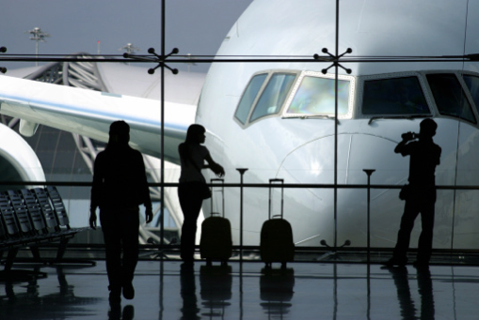
There are four people in the picture. They are waiting at the airport for some reasons. In the backround is a building, probably it’s a part of the airport and there is also a big airplane inside whose a pilot is sitting. The pilot is preparing things which are necessary for the take off. Maybe this will be his first flight so he doesn’t want to make any mistakes. The airplane has impressed the man who really likes it and he is taking a picture of it. The unknown woman standing next to her luggage is maybe his wife or just girlfriend, however she looks bored and maybe a little bit angry because her husband/boyfriend is not interested in her. They are waiting at the airport probably for two reasons. They have arrived earlier just to be sure not to miss their flight or they have just missed it. Furthermore,there is a woman who is approaching them. She is perhaps an airport employee and she is coming to tell them to prepare their boarding passes because their gate is about to open. Personally, when I have to wait at the airport, which is so boring and exhausting, I usually go to the duty-free zone and just buy some chocolate, sweets or perfume. Generally, I think that travelling is perfect, especially to foreign countries beacuse it’s a good way to broaden one´s horizons.
Tomáš Fialka

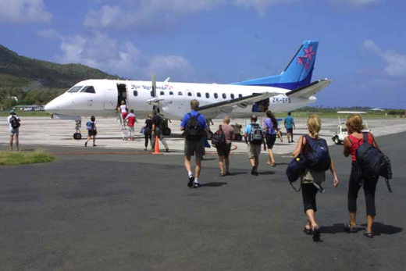
In the picture there are people who are going to board a plane. They are at the airport, specifically on the runway. They are carrying backpacks and hand luggage because the flight will be very long. The plane belongs to budget airlines, so it’s cheaper than a normal airline. It is a sunny, warm day with small clouds in the sky. It looks like nobody has a luggage trolley, so maybe they had left baggage in the left-luggage office. They are perhaps going on a two day trip, so they don’t need many things. They must have a boarding card, which will be checked by the flight attendant when they board the plane. They seem happy and satisfied. Maybe they weren’t waiting for so long in the departure lounge. They have bought some cheap perfumes in the duty-free zone, too. I like this picture. The atmosphere is friendly and I feel relaxed like I’m going with them to some glamorous destination. I also love travelling to foreign countries, especially when I take a plane. When I fly I have the feeling of real freedom, being in the sky with sunlight or moonlight. But if I could, I wouldn’t join the people in the picture because they are all strangers to me, and I need to be with my friends of family.
Saša Supeková

