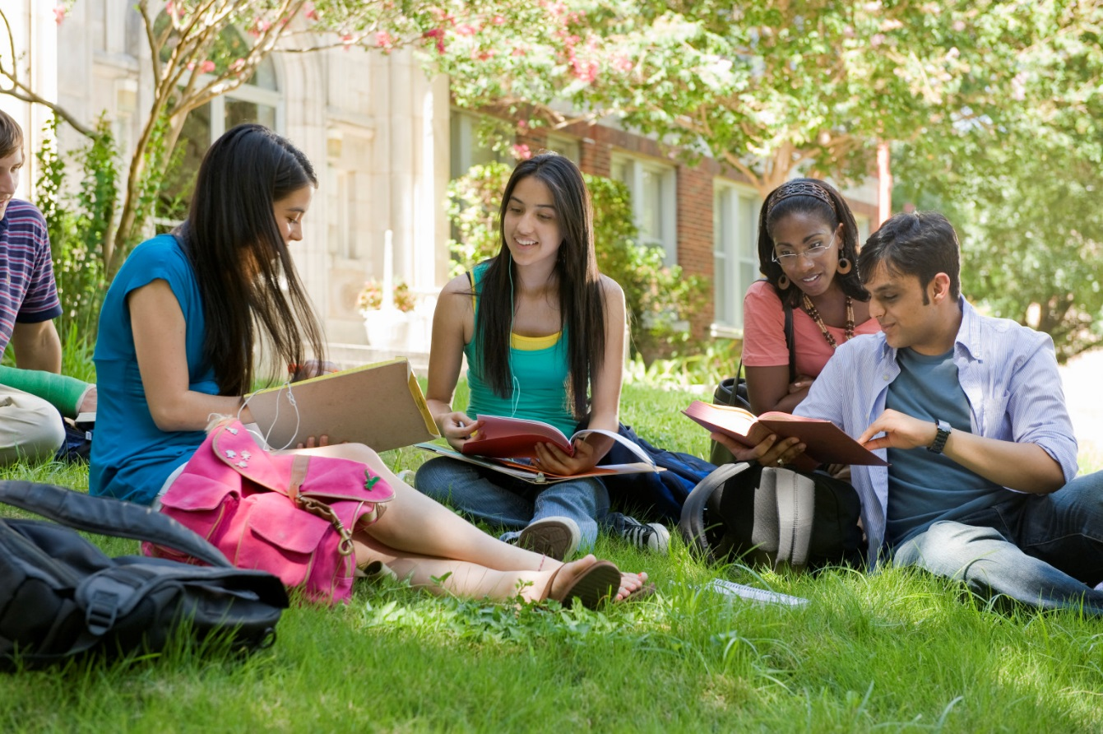
Description of the picture
There are four people in the picture. They are from different ethnic groups so they may be some overseas undergraduates. The students are preparing for final examinations to successfully graduate with a Bachelor of Science degree, I guess. They have been studying at the university for 4 years. The two girls on the left side are studying from their own notes and the boy and girl on the right side are reading a book. The boy may have borrowed the book from the university library. The undergraduates are helping each other with different materials of theirs. The girl in the blue T-shirt is trying to explain the new things that she has been learning for 2 hours to the girl next to her.
They are sitting in a park before their university on a campus. The park is well maintained. There are a lot of blossoming trees that have made the whole park more beautiful. There is even no rubbish there.
I think they are feeling very good and comfortable because the grass is soft. So they can lie down if they want to and have a nap. Furthermore, the weather is lovely and it is not windy so the students are not afraid to put their papers aside.
In my opinion it is better to study outdoors because of fresh air which oxygenates our brains. We will be more creative and relaxed. But at our school, students don´t want to go out to study because there are very loud noises that disturb them. Not every school has some place for outdoor studying. That might be some future idea. So I still study at home.

Tomáš Hlúšek, 2B

